Type of the Paper (Article, Review, Communication, etc.)
Title
Firstname Lastname ¹, Firstname Lastname ² and Firstname Lastname ^{2,}*
Academic Editor: Firstname Lastname
Received: date
Revised: date
Accepted: date
Published: date
Citation: To be added by editorial staff during production.
Copyright: © 2025 by the authors. Submitted for possible open access publication under the terms and conditions of the Creative Commons Attribution (CC BY) license (https://creativecommons.org/licenses/by/4.0/).
¹ Affiliation 1; e-mail@e-mail.com
² Affiliation 2; e-mail@e-mail.com
* Correspondence: e-mail@e-mail.com; Tel.: (optional; include country code; if there are multiple corresponding authors, add author initials)
Abstract
A single paragraph of about 200 words maximum. For research articles, abstracts should give a pertinent overview of the work. We strongly encourage authors to use the following style of structured abstracts, but without headings: (1) Background: Place the question addressed in a broad context and highlight the purpose of the study; (2) Methods: briefly describe the main methods or treatments applied; (3) Results: summarize the article’s main findings; (4) Conclusions: indicate the main conclusions or interpretations. The abstract should be an objective representation of the article and it must not contain results that are not presented and substantiated in the main text and should not exaggerate the main conclusions.
Keywords: keyword 1; keyword 2; keyword 3 (List three to ten pertinent keywords specific to the article yet reasonably common within the subject discipline.)

0. How to Use This Template
The template details the sections that can be used in a manuscript. Note that each section has a corresponding style, which can be found in the “Styles” menu of Word. Sections that are not mandatory are listed as such. The section titles given are for articles. Review papers and other article types have a more flexible structure.
Remove this paragraph and start section numbering with 1. For any questions, please contact the editorial office of the journal or support@mdpi.com.

1. Introduction
Wood has established itself as a strategic structural material in sustainable construction thanks to its renewability, high strength-to-weight ratio, and ability to store carbon, factors that result in lower embodied energy and emissions when compared to steel or concrete [1]. This potential has been expanded by engineered products such as glued laminated timber (Glulam) and cross-laminated timber (CLT), which enable the design of structures with larger spans and reductions of up to 60% in environmental impact over the life cycle of buildings, while providing greater standardization and industrial quality control [2]. Thus, wood has come to be considered a key element in carbon neutrality agendas for medium- and high-rise buildings in several countries, in addition to being a renewable resource.
Among reticulated system solutions, Howe trusses stand out for combining low material consumption, transportability, and faster assembly, key features for industrial roofing, walkways, and temporary modular structures. Recent research shows that, even under normal temperature conditions, the Howe type offers superior performance in minimizing weight, especially for spans over 9 m combined with species of greater mechanical resistance, directly reflecting gains in economic competitiveness [1]. The design of these structures is based on the criteria of strength, stiffness, and overall stability of Eurocode 5 – Part 1-1 [3], which include checks for buckling, composite compression, and permissible deflections in service.
However, the growing adoption of wood on a large scale brings with it the challenge of ensuring fire safety. Above 300 °C, pyrolysis begins, forming a charred layer which, although acting as a temporary thermal insulator, progressively reduces the resistant section of the element [4,5]. To estimate this loss, Eurocode 5 – Part 1-2 [6] provides reduction coefficients for mechanical properties and calculation methods, such as the effective cross-section, which adds a 7 mm “null resistance zone” to the charred depth previously calculated based on the ISO 834 standard curve [7]. These guidelines make it possible to predict with certainty the residual capacity of compressed, tensioned, or flexed bars over different exposure times, providing input for reinforcement or passive protection strategies.
In recent years, bio-inspired algorithms have been used to optimize wooden trusses, with a focus on reducing the total mass of the structure while complying with various regulatory design restrictions. The Firefly Algorithm (FA) stands out for its robustness in global search and the high feasibility rate of the solutions generated, since each firefly is attracted to another with greater light intensity, adjusting its position in a multimodal performance configuration until it converges to global or near-optimal solutions [8]. When integrated with models that simultaneously consider thermal and geometric effects, this algorithm allows the identification of configurations that maintain load-bearing capacity after exposure to fire without resorting to unnecessary oversizing. However, the scientific and technical literature lacks approaches that explicitly incorporate fire-induced degradation mechanisms into structural design optimization routines.
Considering this scenario, this study develops and applies an optimization strategy based on FA for Howe trusses subjected to both ambient and fire conditions, integrating geometric parameters and the thermal-mechanical properties of native Brazilian wood species, namely Cambará-rosa, Cupiúba, Angelim-pedra, Garapa, and Jatobá. Throughout the investigation, the aim is to quantify how fire exposures of 10, 20, and 30 min modify the optimal geometry and structural weight of trusses with spans of 6, 9, 12, and 15 m, in addition to comparing the performance of the five aforementioned species in reducing mass without compromising safety. The study also proposes and validates symbolic regression equations for the gross area correction index (GACI), allowing for quick estimation of the necessary section increase in each group of bars (lower and upper chords, diagonals, main and secondary verticals) for a fire time to be considered by the designer, these equations being fundamental for the pre-dimensioning of flat wooden trusses under fire conditions. In addition, the solutions obtained are verified in light of the Ultimate and Service Limit States of ABNT NBR 7190-1 [9] and the requirements of Eurocode 5 [3,6]; culminating in design guidelines that reconcile material efficiency and fire safety and encourage the sustainable and resilient use of wood for large spans. Having achieved these goals, the work fills gaps in the literature by offering a design method that combines mass optimization, thermal-structural modeling, and analytical expressions of GACI, contributing to the safe and economical adoption of wooden trusses in medium and large buildings.

2. Materials and Methods
This section presents, in detail, the methodology adopted to optimize the weight of wooden trusses considering both normal conditions (t = 0 min) and different fire scenarios (t = 10, 20, and 30 min). Initially, the structural types (Howe) evaluated for spans of 6, 9, 12, and 15 m are described, using five native species (IDs 01 to 05), whose physical and mechanical properties were determined experimentally according to the ABNT NBR 7190-3 standard [10].
Next, the permanent and variable actions are specified according to Brazilian standards ABNT NBR 6120 [11], 6123 [12], and 8681 [13], as well as the load combinations adopted for verification in the ultimate limit state (ULS) and serviceability limit state (SLS).
To incorporate the effects of thermal degradation, the guidelines of Eurocode 5 – Part 1-2 [6] were adopted, which consider the carbonization of the cross section and the reduction of the mechanical and stiffness properties of wood as a function of the time of exposure to fire. The optimization strategy was based on FA, whose general process logic is summarized in Figure 1, which illustrates the methodological flowchart adopted in this study.
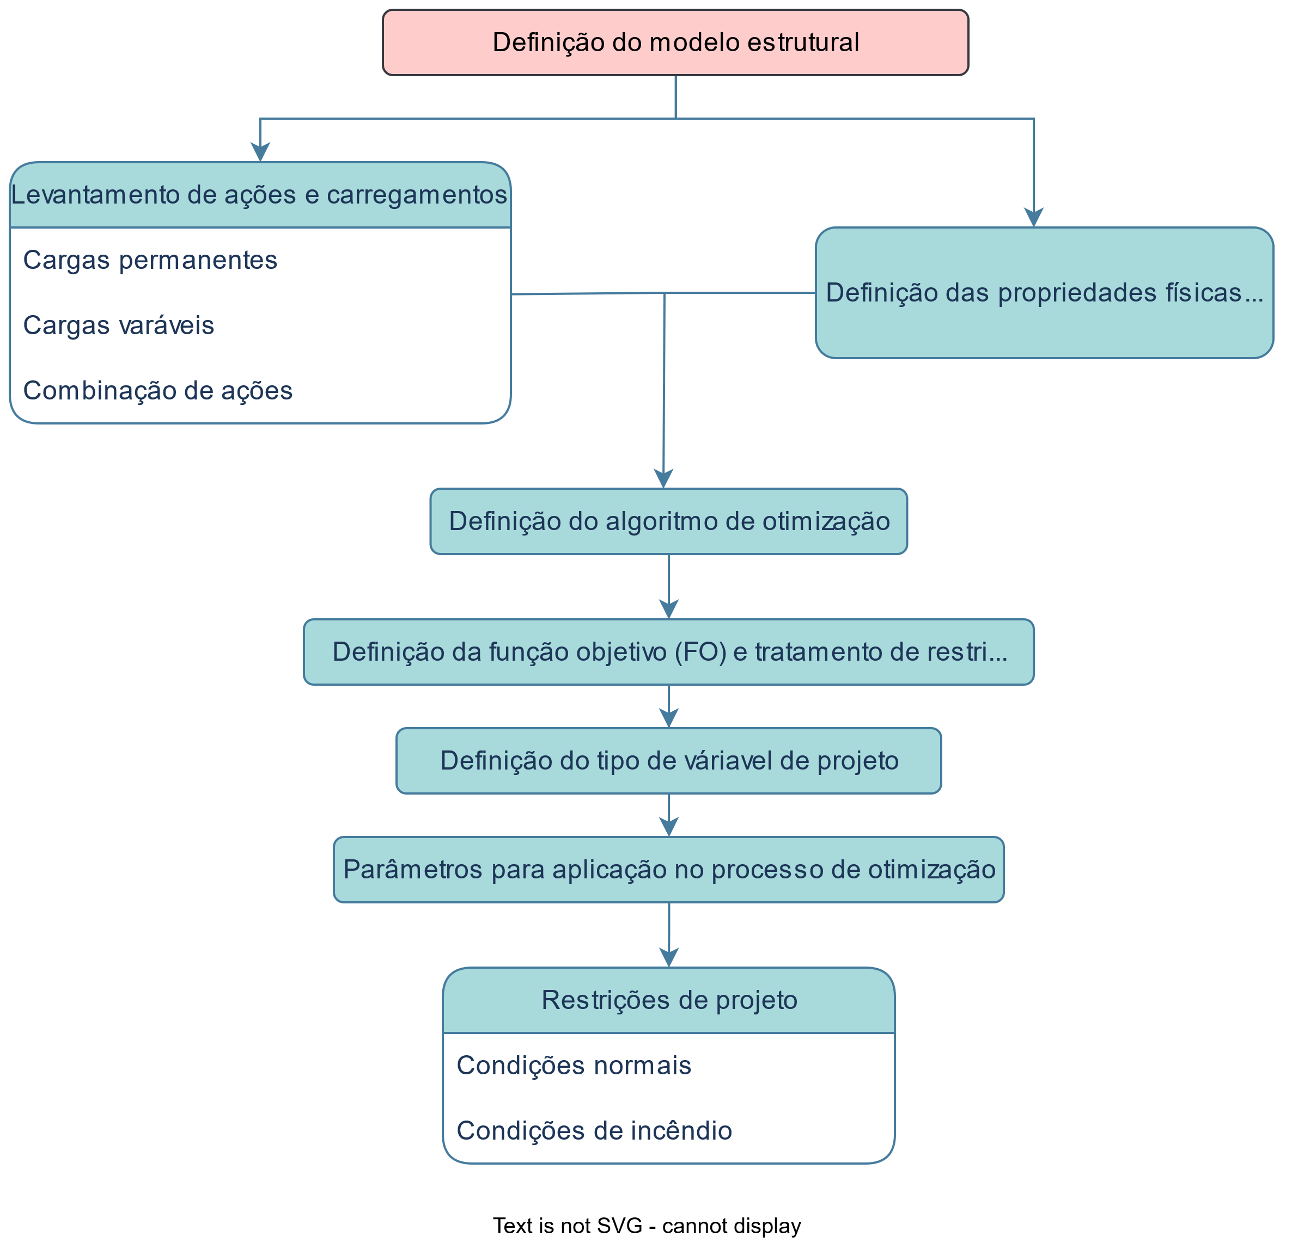
Figure 1. Example

The Materials and Methods should be described with sufficient details to allow others to replicate and build on the published results. Please note that the publication of your manuscript implicates that you must make all materials, data, computer code, and protocols associated with the publication available to readers. Please disclose at the submission stage any restrictions on the availability of materials or information. New methods and protocols should be described in detail while well-established methods can be briefly described and appropriately cited.
Research manuscripts reporting large datasets that are deposited in a publicly available database should specify where the data have been deposited and provide the relevant accession numbers. If the accession numbers have not yet been obtained at the time of submission, please state that they will be provided during review. They must be provided prior to publication.
Interventionary studies involving animals or humans, and other studies that require ethical approval, must list the authority that provided approval and the corresponding ethical approval code.
In this section, where applicable, authors are required to disclose details of how generative artificial intelligence (GenAI) has been used in this paper (e.g., to generate text, data, or graphics, or to assist in study design, data collection, analysis, or interpretation). The use of GenAI for superficial text editing (e.g., grammar, spelling, punctuation, and formatting) does not need to be declared.

3. Results
This section may be divided by subheadings. It should provide a concise and precise description of the experimental results, their interpretation, as well as the experimental conclusions that can be drawn.

3.1. Subsection

3.1.1. Subsubsection
Bulleted lists look like this:
- First bullet;
- Second bullet;
- Third bullet.
Numbered lists can be added as follows:
- First item;
- Second item;
- Third item.
The text continues here.

3.2. Figures, Tables and Schemes
All figures and tables should be cited in the main text as Figure 1, Table 1, etc.

Figure 1. This is a figure. Schemes follow the same formatting.
Table 1. This is a table. Tables should be placed in the main text near to the first time they are cited.
Title 1 | Title 2 | Title 3
entry 1 | data | data
entry 2 | data | data ¹
¹ Tables may have a footer.
The text continues here (Figure 2 and Table 2).
 | 
(a) | (b)
Figure 1. Example
Figure 2. This is a figure. Schemes follow another format. If there are multiple panels, they should be listed as: (a) Description of what is contained in the first panel; (b) Description of what is contained in the second panel. Figures should be placed in the main text near to the first time they are cited.
Table 2. This is a table. Tables should be placed in the main text near to the first time they are cited.
Table 1. Example
Title 1 | Title 2 | Title 3 | Title 4
entry 1 * | data | data | data
 | data | data | data
 | data | data | data
entry 2 | data | data | data
 | data | data | data
entry 3 | data | data | data
 | data | data | data
 | data | data | data
 | data | data | data
entry 4 | data | data | data
 | data | data | data
* Tables may have a footer.

3.3. Formatting of Mathematical Components
This is example 1 of an equation:

a = 1, | (1)

a = 1, | (1)
the text following an equation need not be a new paragraph. Please punctuate equations as regular text.
This is example 2 of an equation:
a = b + c + d + e + f + g + h + i + j + k + l + m + n + o + p + q + r + s + t + u + v + w + x + y + z | (2)
the text following an equation need not be a new paragraph. Please punctuate equations as regular text.
Theorem-type environments (including propositions, lemmas, corollaries etc.) can be formatted as follows:
Theorem 1. Example text of a theorem. Theorems, propositions, lemmas, etc. should be numbered sequentially (i.e., Proposition 2 follows Theorem 1). Examples or Remarks use the same formatting, but should be numbered separately, so a document may contain Theorem 1, Remark 1 and Example 1.
The text continues here. Proofs must be formatted as follows:
Proof of Theorem 1. Text of the proof. Note that the phrase “of Theorem 1” is optional if it is clear which theorem is being referred to. Always finish a proof with the following symbol. □
The text continues here.

4. Discussion
Authors should discuss the results and how they can be interpreted from the perspective of previous studies and of the working hypotheses. The findings and their implications should be discussed in the broadest context possible. Future research directions may also be highlighted.

5. Conclusions
This section is not mandatory but can be added to the manuscript if the discussion is unusually long or complex.

6. Patents
This section is not mandatory but may be added if there are patents resulting from the work reported in this manuscript.
Supplementary Materials: The following supporting information can be downloaded at: https://www.mdpi.com/article/doi/s1, Figure S1: title; Table S1: title; Video S1: title.
Author Contributions: For research articles with several authors, a short paragraph specifying their individual contributions must be provided. The following statements should be used “Conceptualization, X.X. and Y.Y.; methodology, X.X.; software, X.X.; validation, X.X., Y.Y. and Z.Z.; formal analysis, X.X.; investigation, X.X.; resources, X.X.; data curation, X.X.; writing—original draft preparation, X.X.; writing—review and editing, X.X.; visualization, X.X.; supervision, X.X.; project administration, X.X.; funding acquisition, Y.Y. All authors have read and agreed to the published version of the manuscript.” Please turn to the CRediT taxonomy for the term explanation. Authorship must be limited to those who have contributed substantially to the work reported.
Funding: Please add: “This research received no external funding” or “This research was funded by NAME OF FUNDER, grant number XXX” and “The APC was funded by XXX”. Check carefully that the details given are accurate and use the standard spelling of funding agency names at https://search.crossref.org/funding. Any errors may affect your future funding.
Data Availability Statement: We encourage all authors of articles published in MDPI journals to share their research data. In this section, please provide details regarding where data supporting reported results can be found, including links to publicly archived datasets analyzed or generated during the study. Where no new data were created, or where data is unavailable due to privacy or ethical restrictions, a statement is still required. Suggested Data Availability Statements are available in section “MDPI Research Data Policies” at https://www.mdpi.com/ethics.
Acknowledgments: In this section, you can acknowledge any support given which is not covered by the author contribution or funding sections. This may include administrative and technical support, or donations in kind (e.g., materials used for experiments). Where GenAI has been used for purposes such as generating text, data, or graphics, or for study design, data collection, analysis, or interpretation of data, please add “During the preparation of this manuscript/study, the author(s) used [tool name, version information] for the purposes of [description of use]. The authors have reviewed and edited the output and take full responsibility for the content of this publication.”
Conflicts of Interest: Declare conflicts of interest or state “The authors declare no conflicts of interest.” Authors must identify and declare any personal circumstances or interest that may be perceived as inappropriately influencing the representation or interpretation of reported research results. Any role of the funders in the design of the study; in the collection, analyses or interpretation of data; in the writing of the manuscript; or in the decision to publish the results must be declared in this section. If there is no role, please state “The funders had no role in the design of the study; in the collection, analyses, or interpretation of data; in the writing of the manuscript; or in the decision to publish the results”.

Abbreviations
The following abbreviations are used in this manuscript:
MDPI | Multidisciplinary Digital Publishing Institute
DOAJ | Directory of open access journals
TLA | Three letter acronym
LD | Linear dichroism

Appendix A

Appendix A.1
The appendix is an optional section that can contain details and data supplemental to the main text—for example, explanations of experimental details that would disrupt the flow of the main text but nonetheless remain crucial to understanding and reproducing the research shown; figures of replicates for experiments of which representative data is shown in the main text can be added here if brief, or as Supplementary data. Mathematical proofs of results not central to the paper can be added as an appendix.
Table A1. This is a table caption.
Title 1 | Title 2 | Title 3
entry 1 | data | data
entry 2 | data | data

Appendix B
All appendix sections must be cited in the main text. In the appendices, Figures, Tables, etc. should be labeled starting with “A”—e.g., Figure A1, Figure A2, etc.

References
1. Moraes, M.H.M.D.; Fraga, I.F.; Menezes, I.S.; Lahr, F.A.R.; Panzera, T.H.; Freire, R.T.S.; Dias, A.M.P.G.; Santos, H.F.D.; Faustino, E.; Pereira Junior, W.M.; et al. Comparative Analysis of the Mechanical Performance of Timber Flat Truss Typologies for Different Strength Classes via Optimization Algorithm. Buildings 2023, 13, 1946, doi:10.3390/buildings13081946.
2. Dârmon, R.; Lalu, O. The Fire Performance of Cross Laminated Timber Beams. Procedia Manufacturing 2019, 32, 121–128, doi:10.1016/j.promfg.2019.02.192.
3. Comité Europeu de Normalização - CEN EN 1995-1-1: Eurocode 5: Design of Timber Structures - Part 1-1: Design of Timber Structures - Part 1-1: General Common Rules and Rules for Buildings; European Committee for Standardization CEN: Bruxelas - Bélgica, 2004;
4. Kmiecik, K. Impact of Wood Species on the Timber Beam Strength and Stiffness under Fire. IOP Conf. Ser.: Mater. Sci. Eng. 2019, 586, 012004, doi:10.1088/1757-899X/586/1/012004.
5. Zhang, J.; Liu, Z.; Xu, Y.; Ma, S.; Xu, Q. An Experimental and Numerical Study on the Charring Rate of Timber Beams Exposed to Three-Side Fire. Sci. China Technol. Sci. 2012, 55, 3434–3444, doi:10.1007/s11431-012-4996-1.
6. Comité Europeu de Normalização - CEN EN 1995-1-2: Eurocode 5: Design of Timber Structures - Part 1-2: General - Structural Fire Design ; European Committee for Standardization CEN: Bruxelas - Bélgica, 2004;
7. ISO, I.S. ISO 834-1:1999 Fire Resistance Tests — Elements of Building Construction - Part 1: General Requirements ; ISO: Switzerland, 1999;
8. Yang, X.-S. Nature-Inspired Metaheuristic Algorithms; Luniver Press: Frome, 2008; ISBN 978-1-905986-10-1.
9. Associação Brasileira de Normas Técnicas - ABNT NBR 7190-1: Projeto de Estruturas de Madeira. Parte 1: Critérios de Dimensionamento; ABNT: Rio de Janeiro – RJ, 2022;
10. Associação Brasileira de Normas Técnicas - ABNT NBR 7190-3: Projeto de Estruturas de Madeira. Parte 3: Métodos de Ensaio Para Corpos de Prova Isentos de Defeitos Para Madeiras de Florestas Nativas; ABNT: Rio de Janeiro – RJ, 2022;
11. Associação Brasileira de Normas Técnicas - ABNT NBR 6120: Ações Para o Cálculo de Estruturas de Edificações; ABNT: Rio de Janeiro – RJ, 2019;
12. Associação Brasileira de Normas Técnicas - ABNT NBR 6123: Forças Devidas Ao Vento Em Edificações; ABNT: Rio de Janeiro – RJ, 2023;
13. Associação Brasileira de Normas Técnicas - ABNT NBR 8681: Ações e Segurança Nas Estruturas - Procedimento; ABNT: Rio de Janeiro – RJ, 2003;

References must be numbered in order of appearance in the text (including citations in tables and legends) and listed individually at the end of the manuscript. We recommend preparing the references with a bibliography software package, such as EndNote, ReferenceManager or Zotero to avoid typing mistakes and duplicated references. Include the digital object identifier (DOI) for all references where available.

Citations and references in the Supplementary Materials are permitted provided that they also appear in the reference list here.

In the text, reference numbers should be placed in square brackets [ ] and placed before the punctuation; for example [1], [1–3] or [1,3]. For embedded citations in the text with pagination, use both parentheses and brackets to indicate the reference number and page numbers; for example [5] (p. 10), or [6] (pp. 101–105).

- Author 1, A.B.; Author 2, C.D. Title of the article. Abbreviated Journal Name Year, Volume, page range.
- Author 1, A.; Author 2, B. Title of the chapter. In Book Title, 2nd ed.; Editor 1, A., Editor 2, B., Eds.; Publisher: Publisher Location, Country, 2007; Volume 3, pp. 154–196.
- Author 1, A.; Author 2, B. Book Title, 3rd ed.; Publisher: Publisher Location, Country, 2008; pp. 154–196.
- Author 1, A.B.; Author 2, C. Title of Unpublished Work. Abbreviated Journal Name year, phrase indicating stage of publication (submitted; accepted; in press).
- Author 1, A.B. (University, City, State, Country); Author 2, C. (Institute, City, State, Country). Personal communication, 2012.
- Author 1, A.B.; Author 2, C.D.; Author 3, E.F. Title of Presentation. In Proceedings of the Name of the Conference, Location of Conference, Country, Date of Conference (Day Month Year).
- Author 1, A.B. Title of Thesis. Level of Thesis, Degree-Granting University, Location of University, Date of Completion.
- Title of Site. Available online: URL (accessed on Day Month Year).
Disclaimer/Publisher’s Note: The statements, opinions and data contained in all publications are solely those of the individual author(s) and contributor(s) and not of MDPI and/or the editor(s). MDPI and/or the editor(s) disclaim responsibility for any injury to people or property resulting from any ideas, methods, instructions or products referred to in the content.

